Using KidKare.com
ADDING A NEW USER
- Log in to app.kidkare.com.
- From the menu to the left, click Setup.
- Click User Permissions. The User Permissions page opens.
- Click Add User. The Add User pop-up opens.
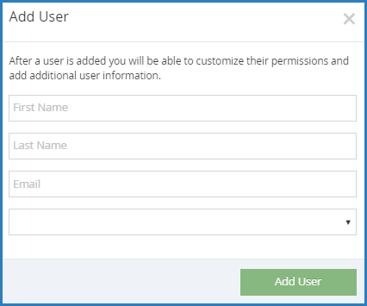
- Enter the user's first name, last name, and email address.
- Do not click the drop-down box.
- Click Add User. The User Added message displays.
- Set a password for the user.
  - Click Email User Instructions to send the user an email containing instructions for accessing their account.
USER DETAILS
- From the menu to the left, click Setup.
- Click User Permissions. The User Permissions page opens to the Users tab by default.
- Locate the user to change. Click Filters to the top-left to filter the user list by status and sort by first or last name.
- Click next to the user to edit. The User Details page opens.
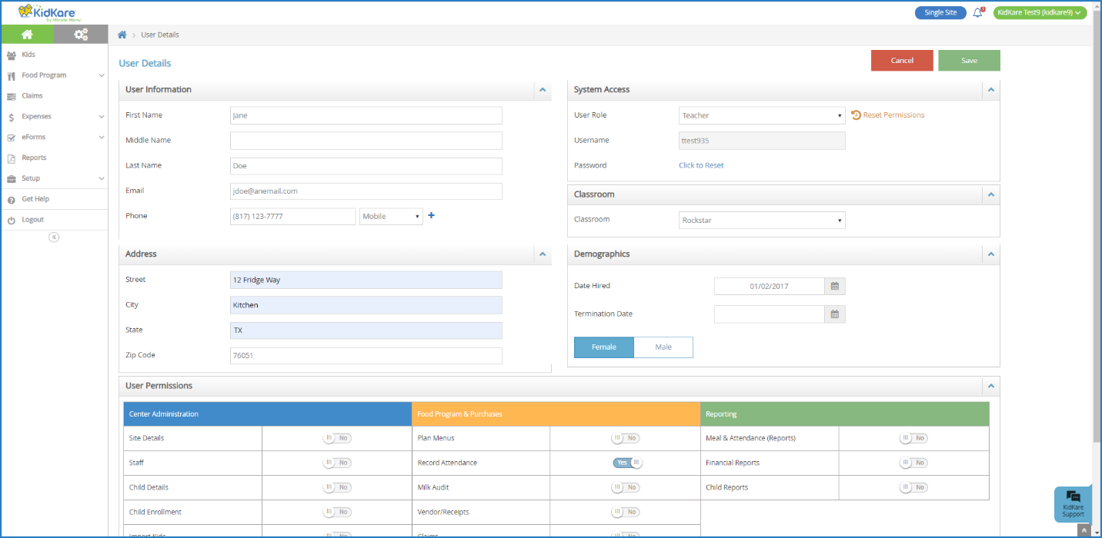
- Click each box and enter new information over the existing information (optional).
- In the User Permissions section, use the sliders to add and remove permissions. Consider the following: Record Center Attendance, Online Enrollment, Assign Classrooms, and Enroll Children.
- When finished, click Save.
RECORDING ATTENDANCE AND MEAL COUNTS
- From the menu to the left, click Menus/Attendance.
- Click Attendance/Meal Counts.
- Make sure the correct date, classroom, and meal are selected at the top. In addition, be sure the Filter is set to Active and Pending children. To do so, select the yellow Filters box in the upper right. Click Active and Pending so they are highlighted in blue. Click on the yellow Filters box again to close the menu.
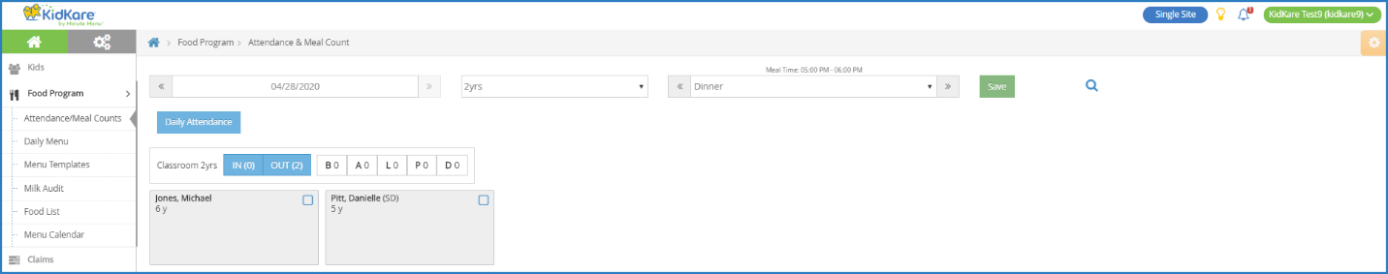
- One method to take attendance is to check the box next to each participant's name then click Save at the top of the page. Another attendance method is to select the blue Daily Attendance box near the top middle section of the page. The Daily Attendance section will open and list all children. Simply click on each child’s name to mark them present and click Save at the bottom.
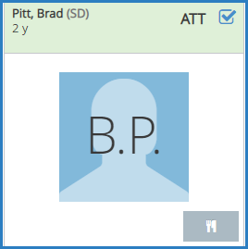
Note: You may be prompted to confirm if a participant you mark present is out of school. If the child is out of school, click OK.
- Click to record a meal count. A participant must be marked in attendance before you can access this option.
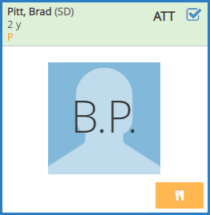
- Note that participants with special diets or allergies noted on their record display with a red outline around their photo.
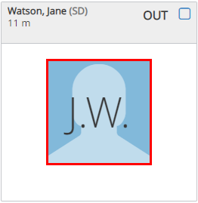
- Click Save.

DASHBOARD
- When you first login to KidKare.com, the Dashboard displays records that require attention. You can navigate to the Dashboard by selecting Children then Dashboard from the menu on the left.
- The Pending Children section lists children that need a valid enrollment form on file to be reimbursed for meals served. Enrollment forms expire annually.
- The Expired/Expiring Enrollments section lists children whose enrollment forms are not yet expired but will soon.
- The Missing Infant Feeding Forms section lists any child under twelve (12) months old that needs a Parent Preference Letter on file. This form indicates who will provide the formula, breast milk, and/or solid foods for infants.
- Click on any child’s name to go to the View Child section for more information and to edit information.
- The View Child section includes a link to download new Enrollment and Income Eligibility forms. KidKare completes some sections of the forms for you so it’s faster for parents/guardians to complete the form(s). Download the pdf and print.
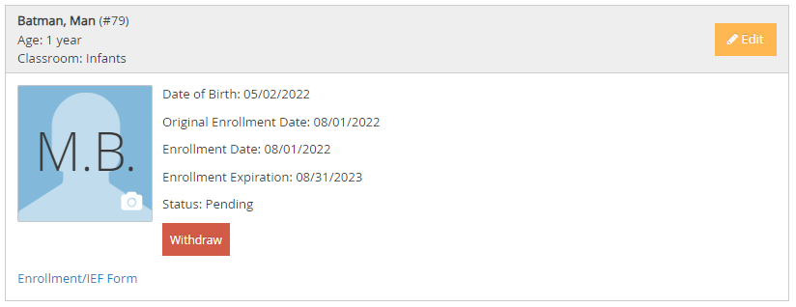

LIST CHILDREN
- The List Children section shows the current roster of children. From the menu on the left, select Children then List Children.
- Children may be filtered in the following ways:
  - Classroom: use the drop-down box to select All Classrooms, or individual classroom names.
  - The yellow box on the top right is a Filter. Click the yellow box to filter by: Active, Withdrawn, Pending, Infant, and/or Non-Infant children. It also allows sorting by first or last name.
  - Click the yellow Filters box to open or close the box. 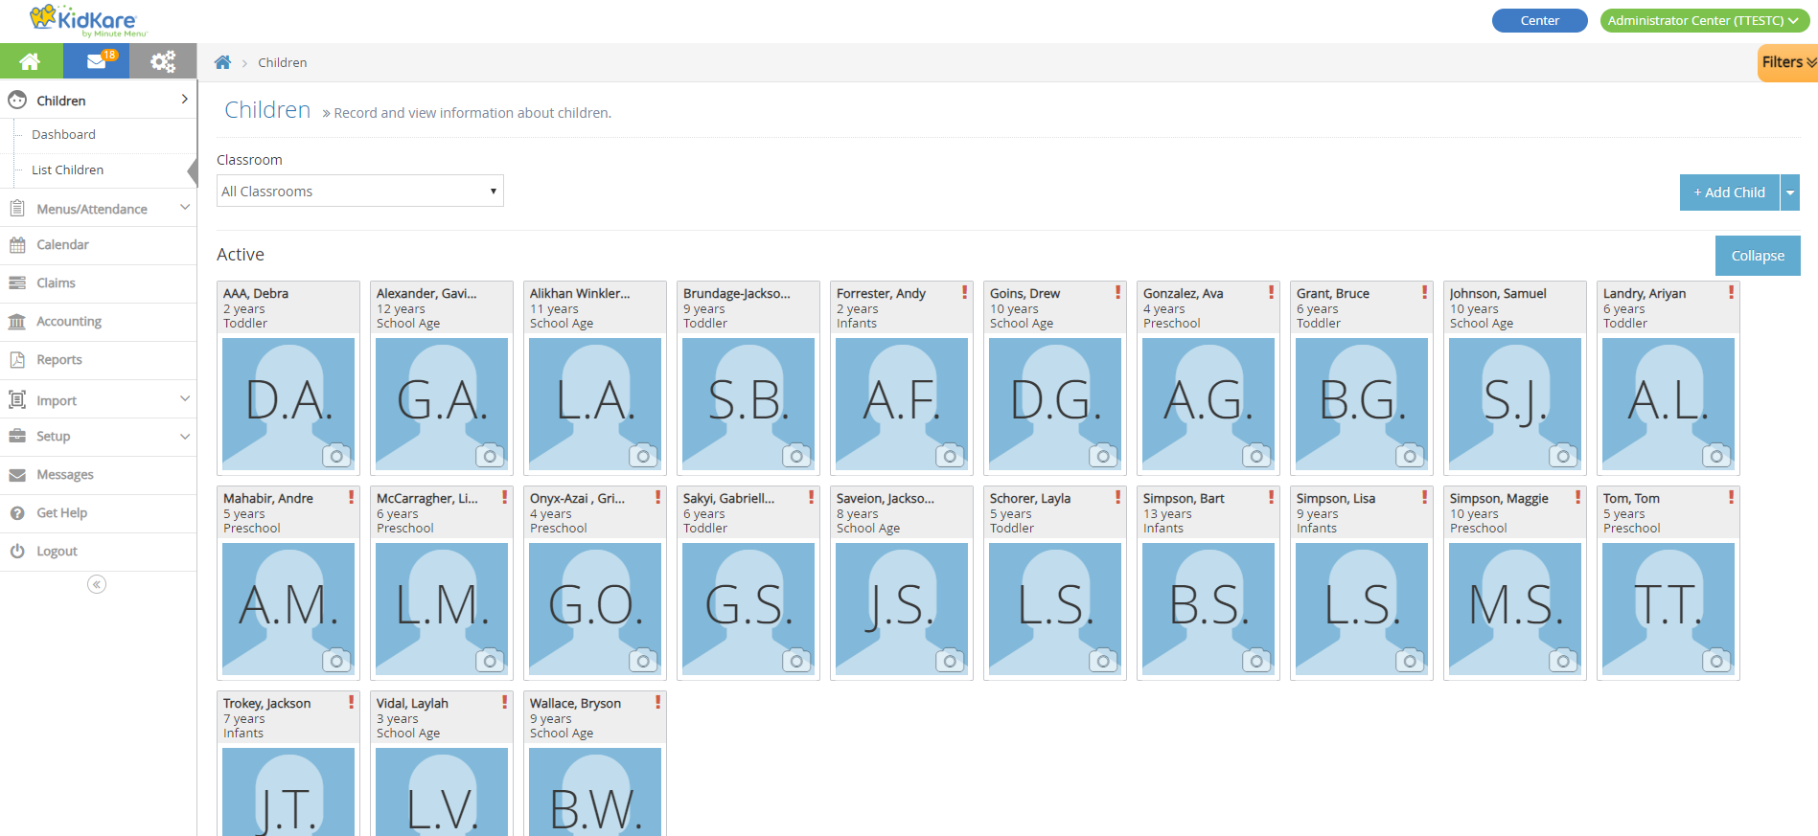
ADDING A NEW PARTICIPANT
- From the menu to the left, click Children then List Children.
- Click the +Add Child box on the right side of the screen.
- In the Name section, enter the participant's first, middle, and last name. You must enter at least a first and last name. 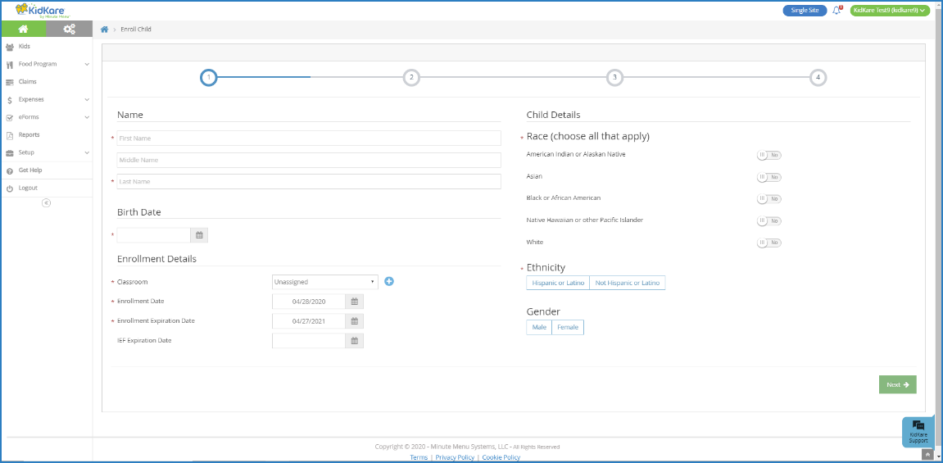
- In the Birth Date section, enter the participant's birth date. You can also click to select the date from a calendar.
- In the Enrollment Details section:
  - Click the Classroom drop-down menu and select the classroom to which to assign the participant you are enrolling. Select Unassigned to assign the participant to a classroom later. You can also click to add a new classroom.
  - Click the Enrollment Date box and change the enrollment date to the 1st of the month. The Enrollment Expiration Date box populates automatically. It is set to the end of the month, one (1) year from the enrollment date you entered.
- In the Child Details section, select the participant's race, ethnicity, and gender.
- Click Next.
  - If you are enrolling a non-infant, the Primary Guardian page opens. Go to Step 10.
  - If you are enrolling an infant, the Infant Details page opens. Continue to Step 8.
- On the Infant Details page: 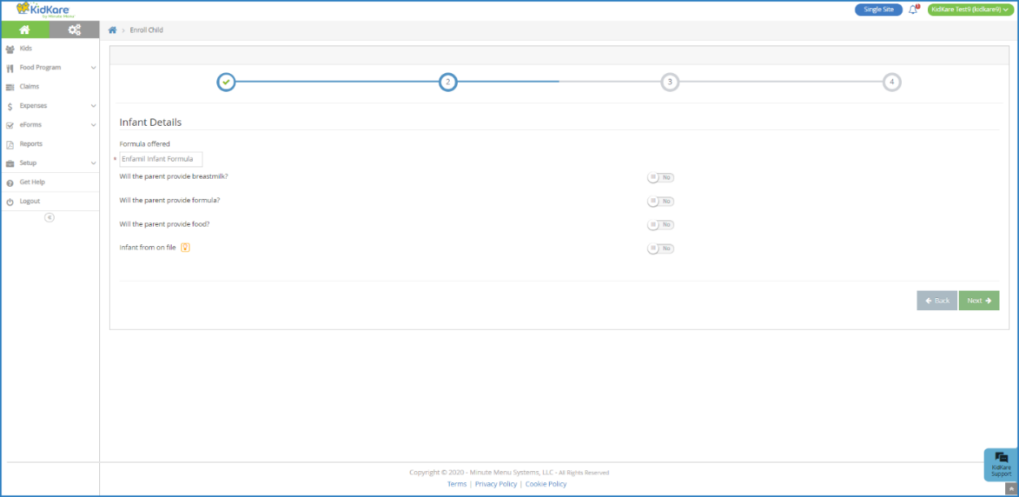
  - Click the Formula Offered box and enter the name of the formula you offer to infants. The formula name you enter here will populate this box automatically for future infant enrollments. This box is required, unless the parent is providing formula/breast milk.
  - If the parent is providing breast milk, click next to Will the Parent Provide Breastmilk.
  - If the parent is providing formula, click next to Will the Parent Provider Formula. If you set this to Yes, you do not have to enter anything in the Formula Offered box. Enter the formula name in the corresponding Name box.
  - If the parent is providing food, click next to Will the Parent Provide Food.
- Click Next. The Primary Guardian page opens.
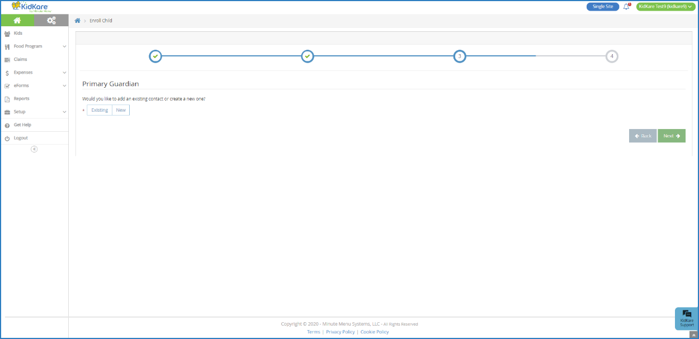

- Add a primary guardian.
  - Click Existing to select an existing parent/guardian. Then, select the contact.
  - Click New to add a new parent/guardian and enter their information.
- Click Next. The final enrollment page opens.
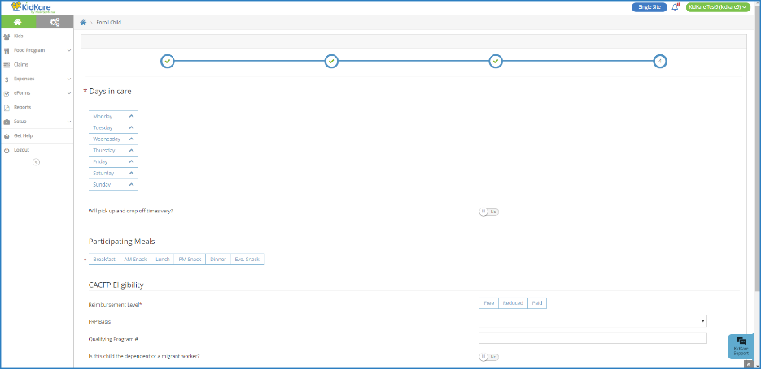
- In the Days in Care section, select the days and times the participant is typically in care.
  - Select the days and in and out times. When entering times, you can click the to select the time with arrows.
  - Click the slider next to Will Pick Up and Drop Off Times Vary if the participant's in/out times vary each day.
  - Click the slider next to Will Child Stay Overnight if the participant will stay at your center overnight at any time.
- In the Participating Meals section, click each meal in which the participant participates.
- In the CACFP Eligibility section, click next to Is this child the dependent of a migrant worker if that is the case.
- Click Enroll Child. The View Child page opens. You can now make changes to this participant's information.
- From the View Child page, click Enrollment/IEF Forms to download and print pre-filled forms for parents’/guardians’ completion.

NEW PROCEDURES FOR SUBMITTING THE MONTHLY CLAIM

By the 10th of the following month, scan and email the following documents to claims@ccresourcesinc.org:
- Menus for the month,
- Staff Time & Duty worksheets,
- Monthly receipts.

